Storyboard of
Storyboard: The Salvation Army Raised Beds 2013-

A new project, using this overgrown area to grow fruit and veg for food boxes, as well as demonstrating what can be grown in a small space and encouraging others to grow for themselves.

Building friendships and opportunities to come together. Sharing knowledge, experience and surplus plants, veg and fruit.

EDCouncil gave us a Grant from the Community Fund to enable us to build quality raised beds.
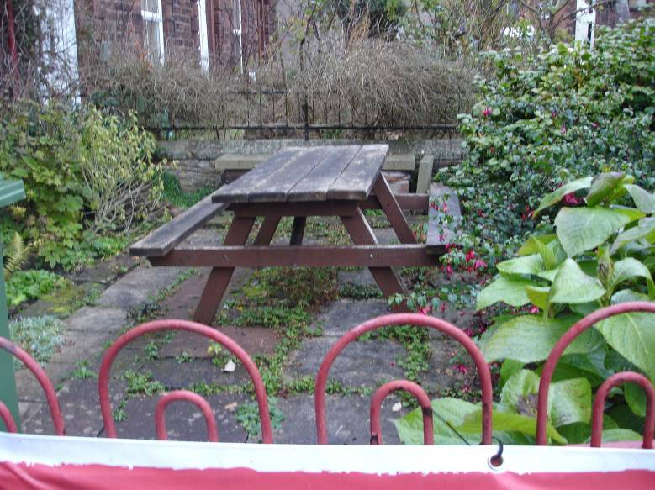

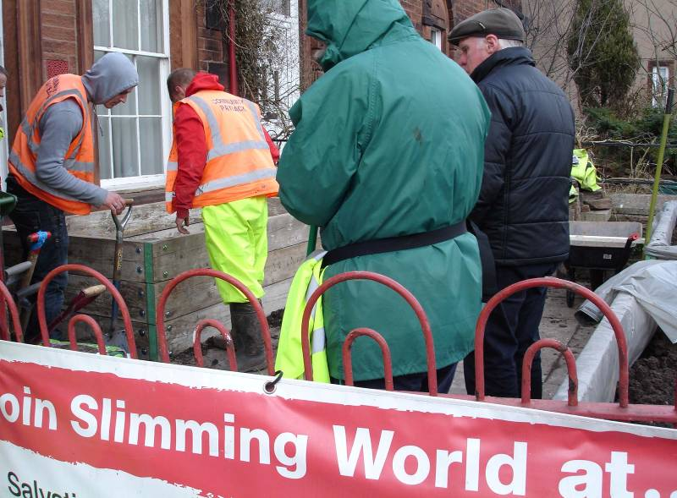

Stage 1-Preparation

Clearing the site. Local residents lent us garden waste bins (saving us £110).

Probation Service ‘Pay Back’ lads cleared the site, useful plants were given away to locals in the area.

Local residents then worked together to build the boxes.

Pay Back lads came again and filled the boxes with soil donated by Metcalfe Plant Hire Ltd

Stage 2- Getting on with the planting

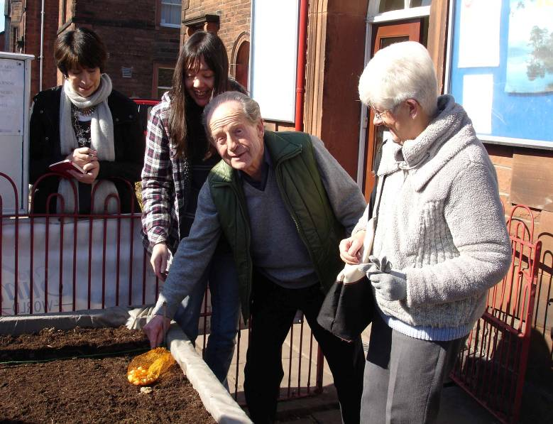

Local residents were invited to plant.

Colin put in the first onion and came every week to check it!

Those no longer fit enough to help stood by and gave advice.

In excess of 90 people have been involved (these are just the ones we know about!)

Young people from the Fantastic Friday Group planted seeds, raspberries & potatoes and helped to water.

A resident gave lots of slates so that information signs could be added.

We were given a variety of plants and a University student added a wormery!

Sheila made Comfrey and Nettle plant feed.

George Bowman gave us horse manure.

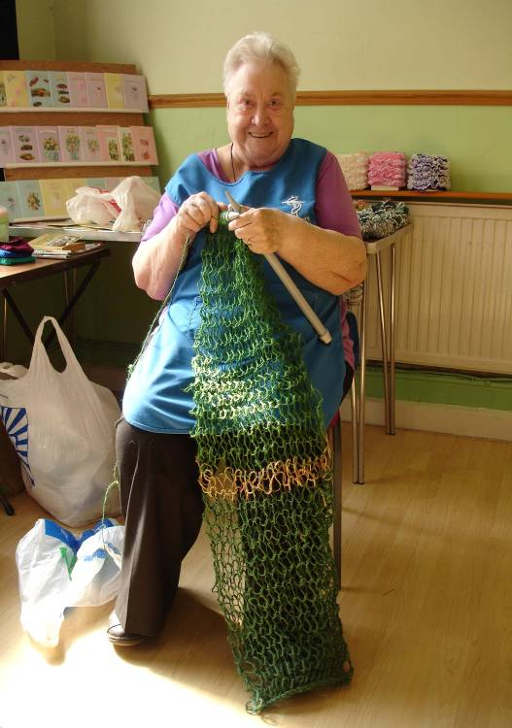
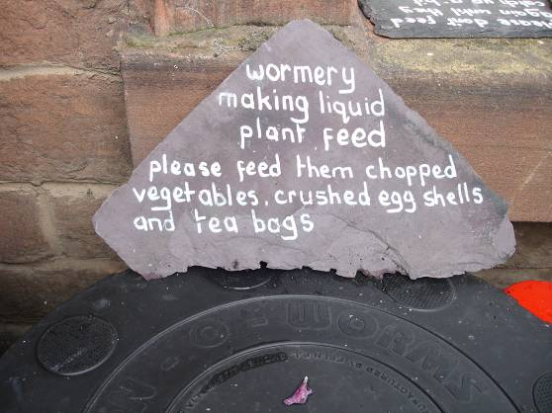
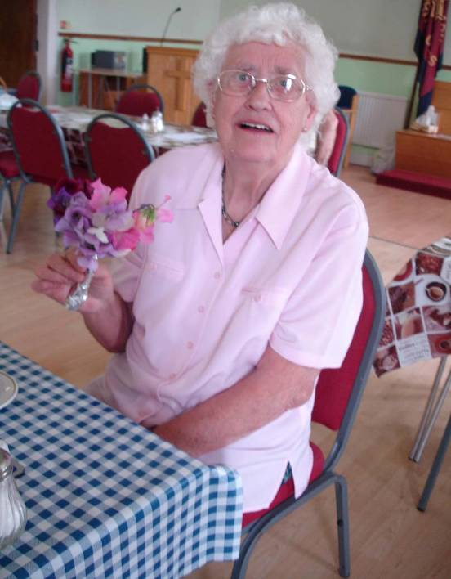
Doreen knitted string netting to support the sweet peas.

Bunches of Sweet Peas were given away throughout the summer to the elderly walking by, at coffee mornings and left on doorsteps as gifts.
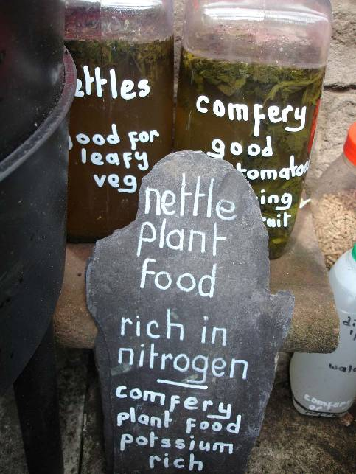

Stage 3- giving it all away!
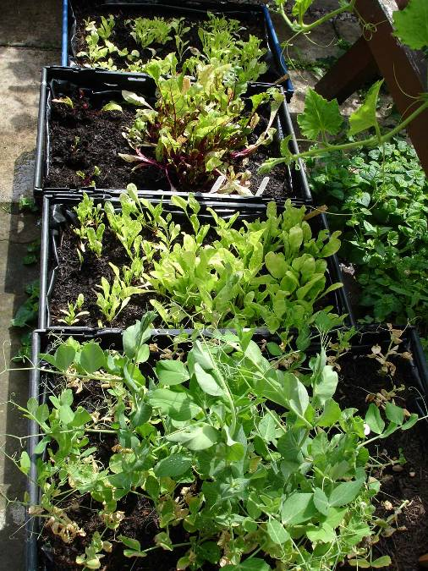
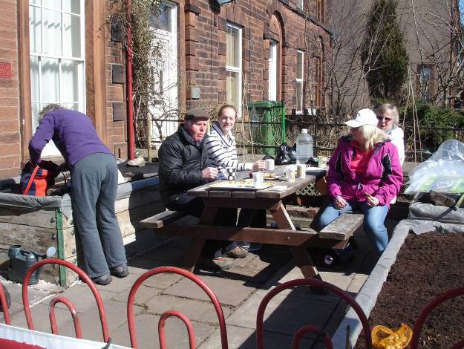
Local residents are invited to weed, water or just sit in this peaceful area.
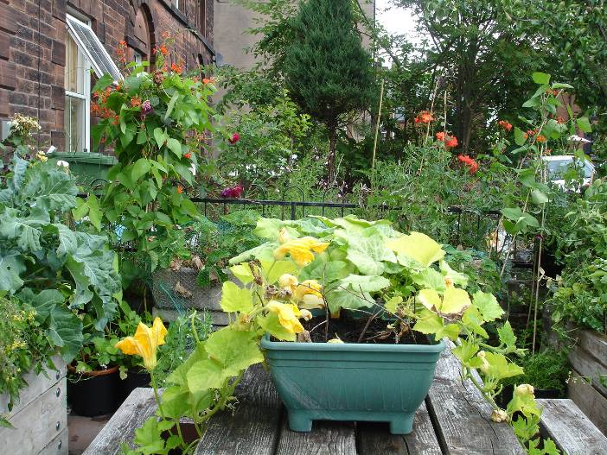

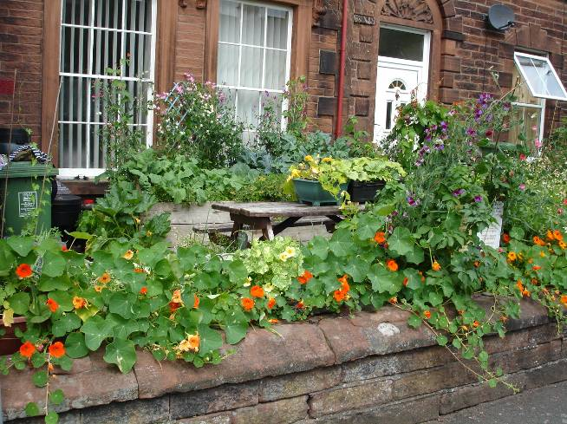
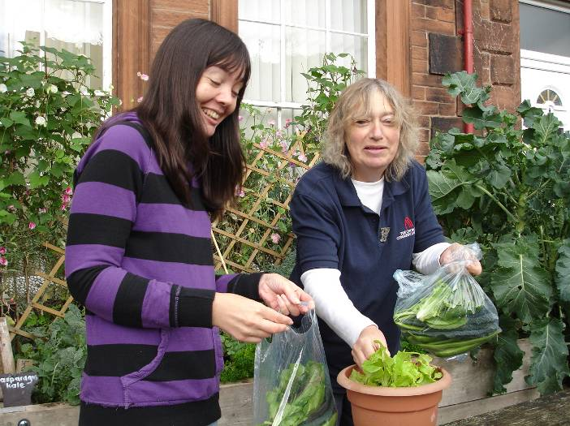
Over 40 food boxes included fresh veg from the beds.

Surplus fruit and veg from other local gardeners wishing to share is left on the picnic bench and wall for people to help themselves for free.
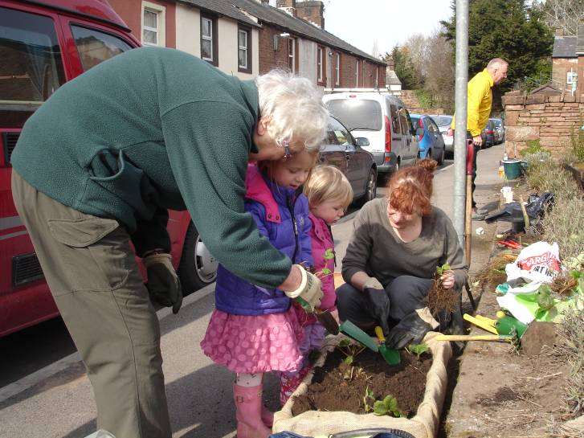
Young volunteers from the Stricklandgate community fruit garden helped to plant up strawberry boxes as a gift for the raised beds.

The development of Community Gardening in Penrith 2012 – 13 includes:
- Herb boxes Penrith Railway Station
- Young people’s Herb Garden at the Town Hall.
- ‘On the Wildside’ Border Foster St
- Sensory borders at 2 garage forecourts
- Stricklandgate Fruit Garden
- URC & Methodist Churches
- WW1 wildflower border
- Raised beds at the Salvation Army

All part of the Penrith Trail
To have created a garden patch is to have succeeded- Emerson. To do it with others, magic!
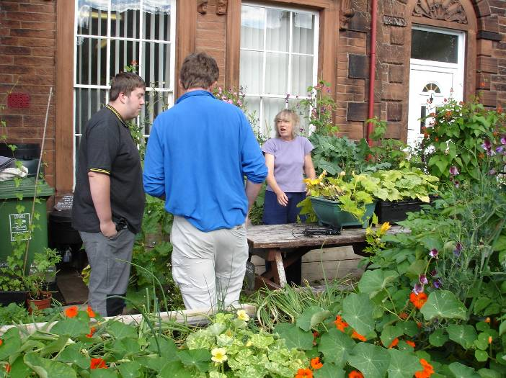
Local residents wishing to build their own beds visit to see how raised beds work and what can be grown.

Over 500 strawberry plants were given away for free at the Stricklandgate fruit garden with instructions on how to grow them.

Blackcurrant bushes are ready for the Spring. A mobile herb garden will appear in town!

The young people from Arthur St learnt how to graft local varieties of eating apples. They will plant these out somewhere in town in the Spring.
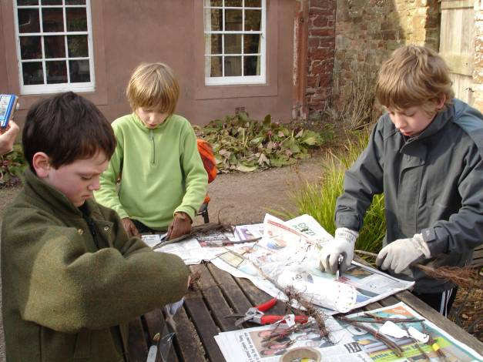
Connecting growing with healthy eating….

100’s of people have made pea shoot planters to take home for free!

Members of the Fantastic Friday Youth Group have started working for the Kitchen Hygiene Certificate. Recently they prepared tasters of different foods for the rest of the group to sample.

In February they will be making ‘Fantastic Soup’ and be invited to serve at the Stone Soup Day (after the success of last year’s event where over 100 bowls of homemade soup were served to the community for free-it’s back on the menu in 2014!).
Thank you to the numerous volunteers who have helped to make this project a success; to Jenny and Stuart at the Salvation Army for being so positive; PACT for trusting us to deliver; Eden DC for helping with the funding; Metcalfe Plant Hire Ltd, JTAtkinsons Ltd, JRichardsons, Probation Service, AWJenkinsons, Newbiggin Sand & Gravel Company, Mountelm, Bells of Lazonby, Starfruits and the kindness of individuals who wanted to help to make a difference, especially to Sheila McDonald one of our community gardeners who worked so hard to make it all happen.

Written up by Joan Robinson Community Gardener


