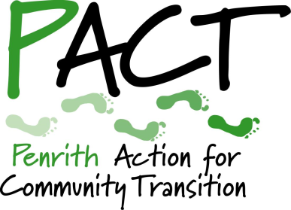
Penrith Action for Community Transition

CONTRACT APPLICATION

Community Action Officer

This form is designed to be completed in Microsoft Word. The document allows you to add lines within boxes and to add rows to tables. Please use Arial font size 11 and do not alter the formatting in other ways.

Please use this application form. Do not send a CV as these will not be considered.

Closing date for return of applications is 12 noon on Friday 27 May 2022.
Candidates shortlisted for interview will be informed by 5pm on Saturday 28 May 2022.
Interviews will be held on Zoom in the evenings of Monday 30 and Tuesday 31 May 2022.

Surname: |  | Forename/s:
Home address:

Address for communications (if different):
Telephone – Home: | Telephone – Other:
Telephone – Mobile: | Email:

Are you a licensed car driver?

Do you have access to a car for work?

Please outline briefly how you plan to travel independently to meetings and events.

Please indicate your earliest start date:

How did you hear about this opportunity?

QUALIFICATIONS
Please give details of qualifications you hold – educational, professional or other. (Separate row for each entry.)
Qualification | Date

OTHER RELEVANT TRAINING
Give details of any other education/training undertaken that you feel is relevant to your application. (Separate row for each entry.)
Subject | Level | Date

EMPLOYMENT
Please tell us about any previous jobs, contracts or volunteer roles that you feel have given you the experience needed to carry out this contract. (Separate row for each entry.)
Employer/client/organisation | Start date | End date | Your role

APPLICABLE SKILLS AND EXPERIENCE
Please outline how your experience would equip you to carry out the assignment and the extent to which you meet the skills and attributes listed in the contract specification. (No more than two A4 pages.)

ADDITIONAL INFORMATION
Please add any other information that you consider relevant to your application. (Up to one A4 page.)

REFEREES
Give the name, occupation, postal address and telephone and/or email details of two people we can approach for a reference. They must not be related to you and at least one referee must be a recent client or employer.
Note: We will only ask for references if you are offered this contract.
1. |  | 2.
Relationship: |  | Relationship:
Current employer/client? |  | Current employer/client?

Canvasing directly or indirectly will disqualify you. You are, of course, welcome to contact us if you have questions before submitting your application. Please email info@penrithact.org.uk.
All information contained in this form will be treated as STRICTLY CONFIDENTIAL.
I declare that the information given in this form is correct to the best of my knowledge.
Date: Name:

Please submit your application form to info@penrithact.org.uk, with ‘CONTRACT APPLICATION’ in the subject line.

