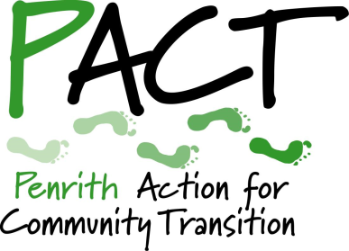
Penrith Action for Community Transition

CONTRACT APPLICATION

Community Action Officer

This application form is designed to be completed in Microsoft Word. The document is unprotected, allowing you to add rows to tables if necessary. Please use font size 11 and do not alter the formatting of the document in other ways.

Please use this application form. Do not send a CV as these will not be considered.

Closing date for return of applications is 9am on Monday 15 March 2021.
Contractors shortlisted for interview will be informed by 5pm on Tuesday 16 March 2021.
Interviews will be held via Zoom on Friday 19 March 2021.

SURNAME |  | FULL FORENAMES
Home address:

Address for communications (if different):
Tel - Home: | Tel - Work:
Tel - Mobile: | Email:

Are you a licensed car driver?

Do you have access to a car for work?

If no, please outline briefly how you plan to travel independently as required by this contract.

If you are not able to begin delivering this contract on 1 April 2021, please indicate your earliest start date:

How did you hear about this contract?

QUALIFICATIONS
Please give details of qualifications you hold (educational, professional or other).
Qualification | Date
If necessary, please add additional rows to the table above to enable you to add details of other qualifications.

OTHER RELEVANT TRAINING
Give details of any other education/training undertaken that you feel is relevant to your application.
Subject | Level | Date
If necessary, please add additional rows to the table above to enable you to add details of other relevant training.

PREVIOUS EMPLOYMENT / CONTRACTS
Please tell us about any previous jobs, contracts or volunteer roles that you feel have given you the experience needed to carry out this contract.
Employer/client | Start date | End date | Your role

If necessary, please add additional rows to the table above to enable you to add details of more roles.

To help us select contractors for interview, please outline how your experience and skills would equip you to carry out the services required in this contract, and the extent to which you meet the skills and attributes listed in the contract specification.
Guidance note: Please submit no more than two A4 pages typed in Arial font, size 11.

ADDITIONAL INFORMATION
Give details of any other information that you consider relevant to your application. (Up to one A4 page using Arial font, size 11)

REFEREES
Give the name, occupation, postal address and telephone or email details of two people whom we can ask for a reference. They must not be related to you. At least one referee must be a recent client or employer.
Note: We will only ask for references if you are offered this contract.
1. |  | 2.
Relationship: |  | Relationship:
Current employer/client? |  | Current employer/client?

Canvasing directly or indirectly will disqualify you. You are, of course, welcome to contact us if you have questions before submitting your application. Please email info@penrithact.org.uk.
All information contained in this form will be treated as STRICTLY CONFIDENTIAL.
I declare that the information contained in this form is, to the best of my knowledge, correct.
Date: Name:

Please submit your application form to info@penrithact.org.uk, with ‘CONTRACT APPLICATION’ in the subject line.

