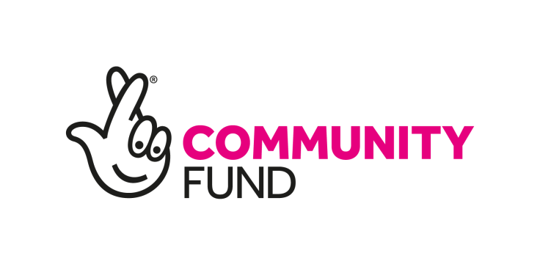
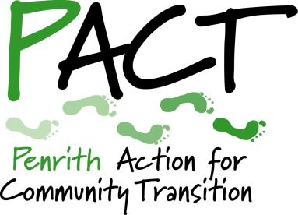

Opportunity to contribute to local environmental survival
PACT Community Action Officer
Penrith Action for Community Transition (PACT) is seeking a part-time Community Action Officer (CAO) to help us realise our community-based environmental activities and meet our commitments as a Delivery Partner under the Zero Carbon Cumbria Partnership (ZCCP) of the project A Zero Carbon Cumbria: by the people for the people, which is funded by the National Lottery’s Climate Action Fund.
This document sets out background information about PACT and ZCCP, the main responsibilities of the self-employed contractor, the skills and experience needed to carry out the various tasks, and the application procedure.

ABOUT PACT
PACT is a community organisation that has been striving to bring about a more sustainable way of life in Penrith and the Eden Valley for more than a decade. Our dedicated team of volunteers run projects and activities to motivate local people to reduce their carbon footprint and environmental impact in a way that builds community connections and resilience.
PACT is committed to promoting community-based responses to the climate emergency and is part of the ZCCP working towards the goal of carbon neutrality for Cumbria by 2037. PACT is supporting Penrith Town Council and Eden District Council to implement their Climate and Ecological Emergency Declarations and fully intends to engage with the Westmorland & Furness Unitary Authority when it assumes the local responsibilities of Eden District Council and Cumbria County Council from 1 April 2023.
To achieve these objectives, our principal aims are to:
- raise awareness of the climate and ecological emergencies;
- reduce local carbon emissions towards the net zero goal;
- increase community resilience to cope better with the growing threats of extreme weather, scarcity of resources and economic instability;
- respond to associated environmental challenges including waste, widespread pollution, loss of habitat and loss of biodiversity;
- collaborate effectively with local governments, businesses, groups and individuals across Eden, harnessing the energies of our local community; and
- add our voice to calls for bold and decisive leadership from the UK Government to respond to the global climate and ecological crisis.
PACT is registered in England as a non-profit Industrial and Provident Society for the Benefit of the Community, (Registration Nº 31972R). For more details, please visit www.penrithact.org.uk.

A Zero Carbon Cumbria: By the people for the people (ZCC)
£2.5 million was secured from the National Lottery’s Climate Action Fund for the five-year ZCC project. The successful bid was led by Cumbria Action for Sustainability (CAfS) on behalf of ZCCP, which comprises more than 80 organisations spanning the public, private and third sectors, with the aim of cutting greenhouse gas emissions. The whole Partnership is involved in promoting decarbonisation programmes to reach the County’s zero-carbon goal. People who live, work and study in Cumbria will be able to take advantage of a range of opportunities to cut their own carbon footprint and that of their communities, playing their part in global actions to respond to climate change. PACT is one of the eleven ZCCP members directly delivering elements of the Lottery-funded initiative.
The Programme is tackling some of the main sources of carbon emissions in Cumbria, with a particular focus on food, energy generation and the goods we buy. The subprojects have been devised by a range of community organisations and chosen because of their wide benefits to local people. More information about the Programme is available here: https://cafs.org.uk/our- projects/zero-carbon-cumbria-programme.

SERVICE CONTRACT SPECIFICATION
CLIENT: Penrith Action for Community Transition (PACT)
LOCATION: Principally working remotely from home base, with attendance at events and meetings across Eden and potentially in other parts of Cumbria. Preferably resident within the Eden Valley to reduce travel cost.
HOURS: Average thirty paid hours a month (about seven hours a week), worked flexibly in accordance with the rolling delivery plan to be agreed by the Contractor and PACT. Occasional evening and weekend working will be required.
RATE: £14.50p an hour, to be invoiced monthly in arrears against timesheets.
DURATION: An initial twelve-month contract with the option to extend on an annual basis thereafter within the duration of the ZCC Programme, which ends on 31 December 2025.
REPORTS TO: The freelance Contractor will report to the PACT Board via our Lead Director for the ZCC Programme.

RESPONSIBILITIES & TASKS

Project delivery
- In close contact with Programme Leads, organise community events, both online and face-to-face, including talks, film screenings, stalls at festival days/shows, public engagement events, training sessions, information displays at public venues, Repair Cafés and Freegle Give-and-Take events. These tasks may involve: booking venues; setting up online events on digital platforms such as Zoom; arranging guest speakers; coordinating volunteers to help run events; and managing bookings and related enquiries.
- Assist with realisation of ongoing and future projects, such as a Tool Library and the establishment of a Climate Hub in a public/community building. Tasks may include: research into how similar projects have been run elsewhere; sharing options and best practice with the PACT Board; target audience research into the feasibility and popularity of project proposals; and recruiting active volunteer members for specific projects.
- Support PACT commitments to mentor newer community sustainability groups in Cumbria and to share learning with others.

Communications & promotion of project activities
- Generate written content about events and activities for the Communications Officer to share via our Newsletter, website, social media, and press releases.
- Collect photographs and video footage of events (with due regard for GDPR) for subsequent publicity.
- Attend events to promote PACT’s work and share knowledge about climate change action and science.
- Promote the wider ZCC activities, such as Citizens’ Juries and Assemblies.
- Utilise existing and new networks to build up the active PACT membership.

Reporting, monitoring & evaluation
- Assist in the collection, archiving and analysis of the information required for reporting to the National Lottery on PACT’s ZCC activities, (whilst adhering to regulations and procedures relating to data protection and information security).
- Liaise with the ZCC Project Manager and the Cumbria Sustainability Network Coordinator, (both based at Cumbria Action for Sustainability).
- Gather and analyse participant feedback on PACT project activities to evaluate their success and potential for improvement.
- Compile case studies showing the positive impact of PACT project activities.

Management & administration
- Liaise closely with PACT ZCC Lead Director through regular catch-up calls.
- Facilitate, attend and follow up on PACT Board and all-member meetings.
- Maintain timesheets and generate invoices monthly in arrears in pro-forma provided to ensure timely payment.

CONTRACTOR SPECIFICATION

Attributes:
- An understanding of the causes and impact of climate change and commitment to PACT’s aims and values.
- Motivation and energy to make a difference.
- Strong existing networks in Eden and Cumbria.

Required skills:
- Carry out basic project and audience research and analysis.
- Plan and organise successful community activities, face-to-face and online.
- Manage own time and workload with minimal supervision.
- Work within a set budget and record budget expenditures.
- Capture learning and use it to improve PACT performance.
- Utilise common software (Microsoft Excel, Word, PowerPoint and Google Drive) with own IT equipment and internet access.
- Accuracy and attention to detail, with good written and proofreading skills and a good level of numeracy.
- Competence in basic photography and video capture.
- Driving licence and access to a vehicle or ability to travel independently as needed.
- Working knowledge of GDPR and other relevant data protection/information security guidelines.

Preferred experience
- Work as part of a wider not-for-profit partnership programme.
- Recruitment, coordination and retention of volunteers.
- Promotion of community events and activities.
- Work with communities in Cumbria, particularly schools, students and young adults.

HOW TO APPLY
To apply for this contract, please complete and submit the application form, which you can download from our website: www.penrithact.org.uk.
Closing date for applications: 12:00 (noon) Friday 27 May 2022.
Selection for interview will be based on application forms only. Interviews will be on Zoom, provisionally scheduled for evenings of Monday 30 and Tuesday 31 May 2022.
Please do not hesitate to contact us if you would like further information about this opportunity on email: info@penrithact.org.uk.

