PACT meeting number 2021-4 – Thursday 6th May 2021
7.30pm via Zoom
Present:
Directors: John Bodger (Chair), Christine Sutherland (Secretary), Frances Bell,
Geoff Rockliffe-King, Lucy Teather, Malcolm Carruthers, Peter Simpson
Members: Ali Ross, Jaki Bell, Joan Robinson, Liz Jablonski, Virginia Taylor
Non-members: Rosie Bradshaw (PACT Community Action Officer), Emma Warner, Helen Attewell (ZCC), Natalie Naismith (ZCC)
1 Apologies
Cecilia Hewitt, Julie Stebbings, Philip Sturgess, Ron Kenyon (Treasurer), Richard Waller, John Forbes (ZCC), Viv Tunnadine (PTC)
2 Declarations of financial interest
None declared
3 Minutes of last meeting
Agreed: Proposed by John, seconded by Geoff
4 Zero Carbon Cumbria
All 12 funded posts within ZCC have now been filled. Two of the new post-holders joined us tonight to tell us about their roles.
a) Natalie Naismith - Local Authority Climate Co-ordinator, based at CCC
There are two aspects to Natalie’s role –
- Supporting CCC, 6 District Councils and some town councils to help them embed climate change and carbon reduction into their decisions and helping them to develop climate action plans.
- Supporting the engagement of the community through setting up Citizens’ Juries (one in each District) and a county-wide assembly and a youth action programme. Working with the Local Authorities to help them to turn the recommendations of the juries into reality, overcoming barriers.
Citizens juries – people will be chosen to be a cross-section of each community, people with different points of view. Each jury will consider questions chosen by the oversight panel for that jury – this includes representatives of organisations including LA.
b) Helen Attewell – Cumbria Sustainability Network Co-ordinator, based at CAfS
Her role is to support us and all the similar groups in Cumbria and encourage the formation of more groups.
- Assisting the Cumbria Sustainability Network with communications and help it be a community of interest and a strong community voice. The network currently meets monthly on Zoom but she hopes there will be a face-to-face event later this year.
- Administering a £100,000 grant pot providing small grants to help set up new groups and projects. Probably small grants under £750, medium grants up to £2,000 and a few larger grants of up to £10,000.
- Encouraging community energy pilot schemes
Big Green Week – Sept 18th to 26th 2021 – is a national week set up by the Climate Coalition. Helen is encouraging the sustainability groups to set up events during this week to raise awareness of COP-26.
5 PACT admin
a) Membership and touchpoints (Rosie)
Rosie is looking into how we revitalise our membership. She will liaise with Jaki re PACT’s Facebook, Twitter and newsletter. We need to decide how often we contact the members and what they expect to get from their membership. Need to check data protection compliance.
b) Hi-vis jackets and litter pickers
John has this in hand. His current stock will be stored at Geoff’s in case anyone wants to use them for the Great Cumbrian Litter Pick on 21 -22 May.
c) Website
Jaki, Chris and Richard have all been too busy to meet recently. Emma would like to join the group.
6 AOB
a) No Mow project - Joan
We agreed that we’d be delighted for the Community Gardeners to run with this this year, using signs that Malcolm has made. Joan and Jaki will liaise about publicity etc.
b) For Peat’s Sake – Jaki - www.forpeatssake.org.uk
Can we support this project? Awareness raising? Have stalls at garden centres?
7 Date of next meeting
Tuesday 1st June, 7.30pm on Zoom.
Agenda items next time – COP-26 events for September, Waste/Single use plastics.

It was suggested that we might invite members of EDC’s Climate Change team (Corentin, Adrian Banford, Jasmine) to a future PACT meeting.

Glossary
CAfS Cumbria Action for Sustainability
CCC Cumbria County Council
EDC Eden District Council
LA Local Authority
PTC Penrith Town Council
ZCC Zero Carbon Cumbria

Reports

Appleby Edibles Community Gardening Update (Lucy)
- 5 yr Licence with EDC signed 26th April.
- A new wheelchair-accessible raised bed is now made and another on the way.
- Green waste generated by Appleby Smarter volunteers being collected weekly and brought back to put into the bottom of deep beds and onto the growing composting area along with donations of manure and fleeces from Stainton.
- Funding from Frieda Scott Charitable Trust of £3,000 confirmed and being released next week.
- Eden Community Fund require a more detailed plan by Monday for £3, 500 applied for.
- AGM and meeting on Sat. May 15th at 2pm.
- I'm making up 'starter packs' to distribute to anyone who would like them in Appleby

Finance Update at 04.05.21 (Philip)
Change since last meeting
Current total: £8,939.38 +£2,314.45
Gardening fund: £2,614.18 -£234.53
Zero Carbon Cumbria: £3335.00 +£2,585.00
Repair café fund: £24.46
Refill fund: £12.41
Donation from Penrith Town Council: £533.00
Unallocated: £2,420.33 -£36.02
Community Gardeners Update (Joan)
1. We are representing Cumbria in Britain in Bloom this year.
2. A trader entered us in a national competition and we won £100 of M&S vouchers.
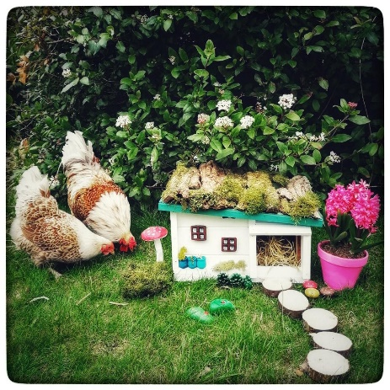
3. 250 sunflower seedlings have been given away.pic
4. We continue to meet on Tuesday mornings and work on our sites then again with 4Eden clients on Thursdays.
5. Gemma one of our gardeners worked on a Wildlife Habitat trail around Penrith -see pic Coronation garden.
6. Poets Walk now being changed. pic
7. We have welcomed Meekuon (from Malaysia) and Thanh (from Vietnam) to our team.
8. We can promote 'No Mow' if PACT not doing it. Malcolm prepared signs last year.

