

RISK ASSESSMENT FORM

Risk Assessment for: | Assessment undertaken by: | Additional signatures: | Assessment reviewed:
Service/Faculty/Dept:  Faculty of Science and Natural Resources, NSF | Name:  Naomi van der Velden | Signature: | Name:
Location of Activity:  Forest garden, National School of Forestry Arboretum, Newton Rigg campus | Date: 28/1/11  February-March 2011 | Name: | Date :
Activity:  Construction of cob oven | Signed by Principal Lecturer or equivalent: | Designation:
Ref: | Date: | Date:

List significant hazards here: | List groups of people who are at risk: |  | List existing controls, or refer to safety procedures etc. | For risks, which are not adequately controlled, list the action needed. | Remaining level of risk: high, med or low
Cuts and bruises | Students, staff, and community advisers and participants |  | Care taken to avoid sharp objects and stones whilst mixing sand, clay and straw. A first aid kit will be available. |  | low
Slips, trips and falls. | Students, staff, and community advisers and participants | Appropriate footwear to be worn. Suitable outdoor clothes to be worn or carried. Debris and obstructions to be identified before work begins and removed if possible. Site to be kept tidy. First aid kit to be available. |  |  | Low
Using a saw | Students, staff, and community advisers and participants | Only to be used by experienced operators or under 1 to 1 supervision. Wear glove on non-sawing hand. Only cut suitably sized wood (to be identified by experienced operators).  Keep hands above and well away from the cutting blades  To be used in activities such as cutting wood. First aid kit to be available. |  |  | Medium
Manual handling | Students, staff, and community advisers and participants | Avoid lifting heavy items (e.g. logs, bricks, stones) where possible, move smaller pieces with care. Careful lifting procedures to be followed. |  |  | Low
Hand Tool maintenance | Students, staff, and community advisers and participants | Wear suitable gloves.  Ensure files and other tools have suitable handles  Wear gloves or use barrier cream  Wash off contamination |  |  | Low
Adverse weather | Students, staff, and community advisers and participants | Appropriate clothing to be worn.  Work to be stopped if too cold/hot or wet to operate safely |  |  | low
Falling objects | Students, staff, and community advisers and participants | Oven supporting base to be constructed from treated timber to ensure longevity. Supporting oven base to be made stable and secure before construction of oven begins. Oven base to be made level at top before construction of oven begins. Oven to be securely fixed to base using cob mixture. All workers to wear sturdy footwear to avoid injury to feet. First aid kit to be available.
Burns | Oven users | Avoid putting hands into oven whilst hot. Cold water located nearby. First aid kit on hand during oven use |  |  | low
Spread of fire | Oven users and people around the immediate area (20 metres) | Fire is fully contained within the oven. Oven is not sited next to inflammable materials 1.5m of clear space around the oven area. Anything inflammable in the immediate areas should be moved at least 10 metres from the oven. Oven not to be left unattended until it has cooled down. Bucket of water and bucket of sand to be nearby during oven use. |  |  | low
Smoke from oven | People around the immediate area (10 metres) | Oven is not open, so smoke should be minimal. Good ventilation of area (roof, but no walls). Space for people to move away from vapours. |  |  | Moderate-low

Emergency Contacts
 |  | Office | Mobile | Home
Newton Rigg contact | Naomi van der Velden
Newton Rigg Reception
 |  |  | ………………………….. | ……………………………
Local Hospital  Carlisle Hospital – All Accident & Emergencies.  Penrith Cottage Hospital – Minor Injuries only, Mon-Fri 9.00-17.00. | 01228 523444  01768 245300
Other (as appropriate)  In the event of Serious Injury or Accident. | 112 or 999

Site visits and Itinerary
Time Location and activity
Various Forest garden, National School of Forestry Arboretum, Newton Rigg campus
Location Maps
Include detailed OS location maps as digital attachments.
Oven to be built on concreted platform underneath roofed area that formerly housed kiln. Adjacent kiln to remain.
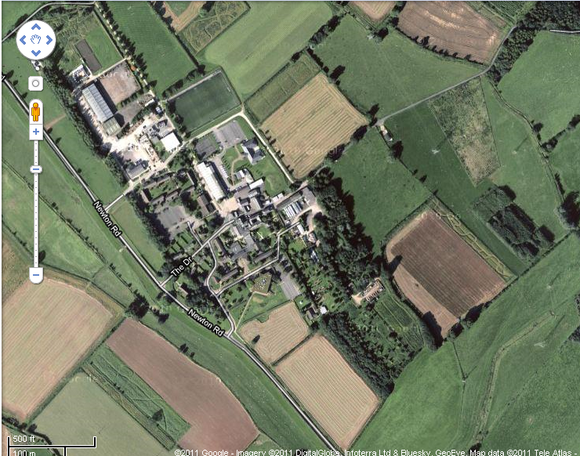
Red circle indicates
location of oven.
Blue square indicates nearest
water source

